PIZZA SALES SQL QUERIES
A. KPI’S
1.TOTAL REVENUE:
SELECT SUM(TOTAL_PRICE) AS TOTAL_REVENUE FROM PIZZA_SALES;
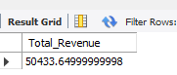

2.AVERAGE ORDER VALUES:
SELECT SUM(TOTAL_PRICE)/COUNT(DISTINCT ORDER_ID) AS AVG_ORDER_VALUE FROM PIZZA_SALES;
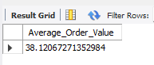

3. TOTAL PIZZA SOLD:
SELECT SUM(QUANTITY) AS TOTAL_PIZZA_SOLD FROM PIZZA_SALES;
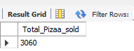

4.TOTAL ORDERS:
SELECT COUNT(DISTINCT ORDER_ID) AS TOTAL_ORDERS FROM PIZZA_DATASET;
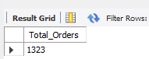

5.AVERAGE PIZZAS PER ORDER:
SELECT CAST(CAST(SUM(QUANTITY) AS DECIMAL(10,2)) /
CAST(COUNT(DISTINCT ORDER_ID) AS DECIMAL(10,2)) AS DECIMAL(10,2))
FROM PIZZA_DATASET;
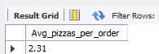

B. DAILY TREND FOR TOTAL ORDERS:
SELECT DAYNAME(ORDER_DATE) AS ORDER_DAY ,
COUNT(DISTINCT ORDER_ID) AS
TOTAL_ORDERS FROM PIZAA_DATASET
GROUP BY DAYNAME(ORDER_DATE)
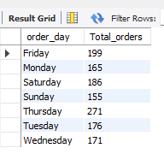

C. HOURLY TREND FOR ORDERS:
SELECT HOUR(ORDER_TIME) AS ORDER_HOURLY,
COUNT(DISTINCT ORDER_ID) AS TOTAL_ORDERS
FROM PIZAA_DATASET
GROUP BY HOUR(ORDER_TIME);
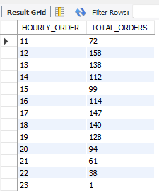

D. PERCENTAGE OF SALES BY PIZAA CATEGORY

SELECT PIZZA_CATEGORY, ROUND(SUM(TOTAL_PRICE),2) AS TOTAL_SALES,
ROUND(SUM(TOTAL_PRICE) * 100 /
(SELECT SUM(TOTAL_PRICE) FROM PIZAA_DATASET),2) AS TOTAL_SALES
FROM PIZAA_DATASET
GROUP BY PIZZA_CATEGORY
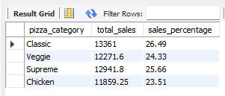

E. PERCENTAGE OF SALES BY PIZAA SIZE
SELECT PIZZA_SIZE, ROUND(SUM(TOTAL_PRICE),2) AS TOTAL_SALES,
ROUND(SUM(TOTAL_PRICE) * 100 / (SELECT SUM(TOTAL_PRICE) FROM PIZAA_DATASET),2) AS SALES_PERCENTAGE
FROM PIZAA_DATASET
GROUP BY PIZZA_SIZE;
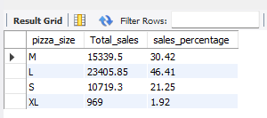

F. TOTAL PIZZA SOLD BY PIZZA CATEGORY
SELECT PIZZA_CATEGORY, COUNT(QUANTITY) AS TOTAL_PIZZAS_SOLD FROM PIZAA_DATASET
GROUP BY PIZZA_CATEGORY;
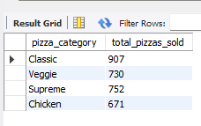
G. TOP 5 BEST SELLERS BY TOTAL PIZZAS SOLD
SELECT PIZZA_NAME, SUM(QUANTITY) AS TOTAL_PIZZAS_SOLD FROM PIZAA_DATASET
GROUP BY PIZZA_NAME
ORDER BY SUM(QUANTITY) DESC
LIMIT 5;
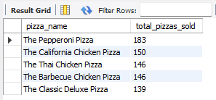

H. BOTTOM 5 WORST SELLERS BY TOTAL PIZZAS SOLD:
SELECT PIZZA_NAME, SUM(QUANTITY) AS TOTAL_PIZZAS_SOLD FROM PIZAA_DATASET
GROUP BY PIZZA_NAME
ORDER BY SUM(QUANTITY) ASC
LIMIT 5;
